

**FINANCIAL MANAGEMENT SYSTEM**

**MINI PROJECT REPORT**

Submitted by:

**TAMILSELVAN A K(231801177)**

VISHVAM GANESH(231801189)

**SOORYA G(231801169)**

CS23332 DATABASE MANAGEMENT SYSTEM

Department of Artificial Intelligence and Data Science

Rajalakshmi Engineering College, Thandalam

**2024-2025**

**BONAFIDE CERTIFICATE**

Certified that this project report “**FINANCIAL MANAGEMENT SYSTEM**” is the bonafide work of **“TAMILSELVAN A K (231801177),VISHVAM GANESH (231801189), SOORYA G (231801169) ”**

who carried out the project work under my supervision.

**Submitted for the Practical Examination held on**

**SIGNATURE SIGNATURE**

|  |  |  |  |  |
| --- | --- | --- | --- | --- |
| **Dr. GNANASEKAR J M** | **Dr. MANORANJINI J** | **Dr.GNANASEKAR J M** | **Dr. MANORANJINI J** | **Dr.MANORANJINI J** |
| **Head of the Department, Artificial intelligence**  **and data Science,Rajalakshmi Engineering College (Autonomous),Chennai-602105** | **Assoc.Professor, Artificial Intelligence and Data**  **Science, Rajalakshmi Engineering College (Autonomous), Thandalam, Chennai-602105** | |  | | --- | | **Head of the Department, Artificial intelligence**  **and data Science,Rajalakshmi Engineering College (Autonomous),Chennai-602105** | | **Professor, Artificial Intelligence and Data**  **Science, Rajalakshmi Engineering College (Autonomous), Thandalam, Chennai-602105** | **Associate Professor, Artificial Intelligence and Data Science, Rajalakshmi Engineering College,(Autonomous), Thandalam, Chennai-602105** |

**INTERNAL EXAMINER EXTERNAL EXAMINER**

**TABLE OF CONTENT**

|  |  |  |
| --- | --- | --- |
| **S.NO** | **CHAPTER** | **PAGE NUMBER** |
| 1. | **INTRODUCTION** |  |
| 1.1 | GENERAL | 7 |
| 1.2 | OBJECTIVES | 7 |
| 1.3 | SCOPE | 8 |
| 2. | **SYSTEM OVERVIEW** |  |
| 2.1 | SYSTEM ARCHITECTURE | 9 |
| 2.2 | MODULES OVERVIEW | 10 |
| 2.3 | USER ROLES AND ACCESS LEVELS | 11 |
| 3. | **SURVEY OF TECHNOLOGIES** |  |
| 3.1 | SOFTWARE AND TOOLS USED | 12 |
| 3.2 | PROGRAMMING LANGUAGES | 12 |
| 3.3 | FRAMEWORKS AND LIBRARIES | 13 |
| 4. | **REQUIREMENTS AND ANALYSIS** |  |
| 4.1 | FUNCTIONAL REQUIREMENTS | 14 |
| 4.2 | NON-Functional Requirements | 14 |
| 4.3 | HARDWARE AND SOFTWARE REQUIREMENTS | 14 |
| 4.4 | ARCHITECTURE DIAGRAM | 14 |
| 4.5 | ER DIAGRAM | 15 |

|  |  |  |  |
| --- | --- | --- | --- |
| 5. | **SYSTEM DESIGN** | |  |
| 5.1 | DATABASE DESIGN AND TABLES | | 16 |
| 5.2 | UI DESIGN OVERVIEW | | 16 |
| 5.3 | WORKFLOW AND PROCESS DIAGRAMS | | 17 |
| 6. | **IMPLEMENTATION** | |  |
| 6.1 | CODE STRUCTURE AND ORGANIZATION | | 18 |
| 6.2 | KEY MODULES AND THEIR FUNCTIONS | | 20 |
| 6.3 | CHALLENGES AND SOLUTIONS | | 21 |
| 7. | **TESTING AND VALIDATION** | |  |
| 7.1 | TESTING STRATEGIES | | 22 |
| 7.2 | TEST CASES AND RESULTS | | 22 |
| 7.3 | BUG FIXES AND IMPROVEMENTS | | 23 |
| 8. | **RESULTS AND DISCUSSION** | |  |
| 8.1 | SUMMARY OF FEATURES | | 24 |
| 8.2 | USER EXPERIENCE FEEDBACK | | 24 |
| 8.3 | POTENTIAL IMPROVEMENTS | | 25 |
| 9 | **CONCLUSION** | | 28 |
| 10 | **REFERENCES** | 29 | |

**TABLE OF FIGURES**

|  |  |  |
| --- | --- | --- |
| **S.NO** | **FIGURE** | **PAGE NUMBER** |
| 1 | ARCHITECTURE DIAGRAM | 14 |
| 2 | ER DIAGRAM | 15 |
| 3 | WORK FLOW DIAGRAM | 17 |
| 4 | DASHBOARD | 26 |
| 5 | ADD CASH TO BALANCE | 26 |
| 6 | TRACK EXPENSES | 27 |
| 7 | EXPENSE CATEGORIES | 27 |
|  |  |  |
|  |  |  |
|  |  |  |
|  |  |  |
|  |  |  |
|  |  |  |
|  |  |  |
|  |  |  |

## ABSTRACT

The Financial Management System is a web-based application designed to help users efficiently manage and analyze personal finances. With an intuitive interface, the system enables users to record expenses, categorize transactions, and monitor spending trends over time. Key features include budget tracking, expense categorization, and financial insights, empowering users to make informed decisions and maintain control over their finances.

Built using modern web technologies, the application ensures a seamless user experience and incorporates a secure backend to protect financial data. Visual tools, such as charts and graphs, present financial information clearly, helping users identify trends and optimize spending habits.

By simplifying financial management and providing actionable insights, the system aims to improve financial literacy and encourage better financial habits, ultimately empowering users to achieve stability and confidence in their financial decisions.

**1. INTRODUCTION**

* 1. **General**

This report details the development of a comprehensive Financial Management System designed to streamline the tracking and management of personal finances. With an increasing need for individuals to maintain control over their spending habits, this system seeks to offer an organized and systematic approach to managing personal expenses. Leveraging structured design principles and efficient code implementation, the system offers an intuitive, user-friendly experience tailored to assist users in achieving greater financial awareness and control.

The Financial Management System addresses common challenges faced in personal finance management, such as manually tracking multiple expense categories and analyzing spending patterns. By using a web-based interface, this system provides easy access to essential financial tools, allowing users to record transactions, categorize expenses, and view reports on their financial activities. This system has been designed to cater to a wide range of users, from those with minimal budgeting experience to more financially experienced individuals, by prioritizing ease of use and accessibility.

**1.2 Objectives**

The main objectives of the Financial Management System are:

* Expense Tracking Across Categories: Develop a system that efficiently tracks user expenses across multiple categories, ensuring a clear breakdown of where and how funds are being spent.
* User-Friendly Interface: Provide a simple, intuitive interface that enables users to easily add, update, and view their financial records without requiring extensive technical knowledge.
* Financial Analysis and Reports: Generate detailed summary reports that allow users to analyze their spending patterns, identify areas for improvement, and make informed financial decisions.

In addition to these objectives, the system aims to support periodic data analysis, encouraging users to regularly review and improve their financial management practices.

**1.3 Scope**

The scope of this Financial Management System encompasses a range of features that allow users to manage their personal finances effectively. The system enables users to:

* Track Income and Expenses: Record and categorize income and expenses to maintain a comprehensive view of their finances. Users can specify categories for each transaction, facilitating better financial tracking and accountability.
* Visualization of Spending Habits: Access graphical representations of spending habits, such as charts and summaries, to quickly understand spending trends and identify patterns.
* Efficient Record Management: Through a web-based interface, users can add, edit, and delete records conveniently, ensuring that the data remains up-to-date and accurate.

Beyond individual expense tracking, the system also offers additional functionalities, including the ability to filter records by date, category, or amount, thus enabling users to analyze spending over specific periods or within particular categories. This functionality is crucial for users who want to assess their financial performance in more detail, such as comparing monthly or quarterly spending.

Extended Functionalities and Future Enhancements

As a long-term goal, this system can be further enhanced to include features such as budgeting tools, savings goals, and debt management. Additionally, integration with external financial sources, like bank accounts or credit card statements, could allow automatic imports of transactions, significantly reducing manual entry.

**2. SYSTEM OVERVIEW**

**2.1 System Architecture**

The Financial Management System is designed using a three-tier architecture that ensures efficient processing, organized data management, and enhanced security. This architecture consists of three main layers:

* Front-End Interface: The front-end is the user-facing component, providing an interactive web-based interface through which users can perform essential actions like adding, updating, and viewing financial records. This layer is designed with simplicity in mind, prioritizing user experience and ease of navigation. Utilizing responsive design principles, the front-end adapts to various devices, allowing users to access their financial data on desktops, tablets, and mobile phones.
* Middle Layer (Data Processing): The middle layer serves as the system’s logic core, where all data processing occurs. It bridges the front end with the backend by handling data validation, processing requests, and managing business logic. This layer ensures that user actions on the front-end, such as categorizing expenses or generating reports, are executed smoothly and efficiently. By employing RESTful APIs, this layer allows for scalable data processing and potential integration with external applications in the future, such as budget calculators or external financial data sources.
* Backend Database: The backend is the storage layer where all user data is securely maintained. It employs a relational database management system (RDBMS) to store, retrieve, and manage data efficiently. The backend database is structured to store various categories of user data, including income, expense records, and report histories. Security protocols, such as encryption and user authentication, are implemented to ensure data integrity and prevent unauthorized access.

This architecture allows for modular development and easier maintenance, where updates or changes to one layer do not disrupt the functionality of others, making the system highly adaptable and scalable.

**2.2 Modules Overview**

The Financial Management System is composed of several key modules, each serving a specific function within the system. The primary modules include:

* Expense Tracking: This module enables users to add, categorize, and manage their expenses. Each transaction can be assigned to a specific category (such as groceries, utilities, or entertainment) to provide a detailed breakdown of spending. Users can set up recurring expenses, making it easier to track monthly or annual subscriptions. Additionally, this module includes editing and deletion functionalities, allowing users to keep their records accurate and up-to-date.
* Reporting: The reporting module generates detailed and summary reports based on user-defined criteria. Users can filter reports by date range, category, or amount to gain insight into their financial habits. This module offers visualizations such as pie charts, bar graphs, and trend lines, enabling users to analyze their data effectively. Users can export reports in various formats (PDF, CSV) for offline review or integration with other tools, making this module highly versatile.
* Data Management: Responsible for all database operations, the data management module manages data storage, retrieval, and updates within the backend. It employs SQL queries to fetch data quickly and efficiently, ensuring a seamless experience for the user. This module also includes a backup feature to prevent data loss, as well as data validation mechanisms to ensure the accuracy and consistency of stored information. Data management is integral to the smooth functioning of the application, as it underpins all other modules by managing the data lifecycle effectively.

These modules work together to create a cohesive system that provides users with a comprehensive toolkit for financial management.

**2.3 User Roles and Access Levels**

Currently, the Financial Management System is designed for individual use, meaning there are no separate user roles or hierarchical access levels. Every user has full access to their own records, which keeps the system straightforward and tailored to personal finance management. However, to ensure data security, access to the backend database is restricted to authenticated users only, preventing unauthorized access to sensitive financial information.

While this system is single-user-focused, the backend architecture has been designed with scalability in mind. This means that future versions of the system could incorporate multi-user capabilities, allowing for different user roles (e.g., family members with shared accounts or financial advisors with limited access).

Additionally, secure authentication protocols are in place to protect user data from unauthorized access, making the system robust even in its single-user configuration.

**2.4 Potential Enhancements for User Access**

As a potential enhancement, the system could support multi-user access levels, catering to individuals with varying permissions. This could include roles such as "User," "Administrator," or "Guest." The Administrator role might grant access to advanced features, such as budgeting tools or enhanced reporting, while the Guest role could provide limited access to view-only reports, useful for sharing financial data with others without compromising data privacy.

This modular design and extensibility ensure that the Financial Management System can grow and adapt to meet evolving user needs, providing a sustainable solution for long-term financial management.

**3. SURVEY OF TECHNOLOGIES**

**3.1 Software and Tools Used**

The development of the Financial Management System utilizes a suite of programming languages, tools, and frameworks designed to facilitate efficient data processing, user interface development, and database management. The core components include:

* Python: The primary language for backend processing, responsible for handling business logic, data processing, and communication with the database.
* SQL: Utilized for managing structured data storage, ensuring efficient data retrieval and manipulation for the system.
* HTML/CSS/JavaScript: Employed in creating the front-end user interface, these languages provide a responsive, interactive, and user-friendly experience.

The system is built on the Flask web framework, which seamlessly links the front-end interface with backend operations, allowing for a smooth user experience and efficient data handling.

**3.2 Programming Languages**

The Financial Management System leverages multiple programming languages, each fulfilling a specific role within the application:

* SQL: SQL is employed for structuring and managing the database. This language allows for complex data querying and efficient data storage, making it ideal for handling the various financial records stored within the system. SQL enables users to retrieve, update, and manage records accurately and efficiently.
* Python: Python powers the backend logic and data handling operations. Known for its readability and flexibility, Python is an optimal choice for handling calculations, data validation, and data processing tasks. It manages all backend functionalities, including data insertion, updating, and the generation of financial reports.
* HTML/CSS/JavaScript: The combination of HTML, CSS, and JavaScript forms the backbone of the system’s front-end design. HTML provides the structure, CSS enhances the visual layout, and JavaScript introduces interactivity, allowing users to engage with features such as form submissions, record editing, and dynamic report generation. Together, these languages create a responsive and engaging interface that accommodates a range of devices and screen sizes.

**3.3 Frameworks and Libraries**

To streamline development and enhance functionality, the system incorporates several frameworks and libraries, including:

* Flask: Flask is a lightweight, yet powerful web framework that serves as the primary platform for this application. Flask facilitates the connection between the front-end and backend, enabling seamless communication between the user interface and the data processing logic. Flask’s modular nature makes it a suitable choice for building scalable applications with minimal overhead.
* SQLAlchemy: SQLAlchemy is an Object-Relational Mapping (ORM) library in Python, used to handle database operations within the system. By abstracting the SQL commands into Python code, SQLAlchemy simplifies the interaction with the database, enabling efficient data querying and manipulation. This ORM tool also enhances security by mitigating risks associated with raw SQL queries, such as SQL injection. Additionally, SQLAlchemy improves data handling efficiency, making it easier to maintain complex database interactions while keeping code readable and maintainable.

These frameworks and libraries contribute to a cohesive and functional system, offering a solid foundation for future expansion and improvements. Each component plays a vital role in creating an efficient, user-friendly Financial Management System, balancing ease of use with powerful data handling capabilities.

**4. REQUIREMENTS AND ANALYSIS**

**4.1 Functional Requirements**

* The system should allow users to add, view, and delete expenses.
* It must generate reports by category, date, and amount.

**4.2 Non-Functional Requirements**

* The application should be responsive and load quickly.
* Data security is essential to protect user financial records.

**4.3 Hardware and Software Requirements**

* **Hardware**: Standard PC or server with internet access.
* **Software**: Web browser, Python, Flask, SQL database.

**4.4 Architecture Diagram**

The architecture diagram represents the interaction between the frontend, backend, and database layers.

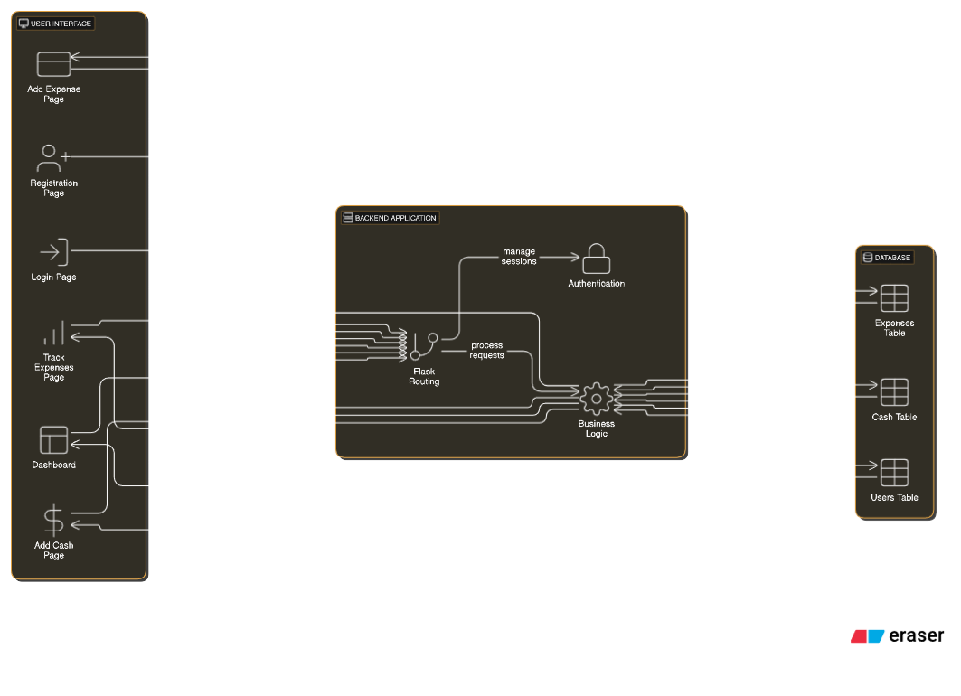

**Fig. 1. Architecture Diagram**

**4.5 ER Diagram**

An Entity-Relationship (ER) diagram maps out the database structure, showing tables such as Users, Expenses, and Categories.

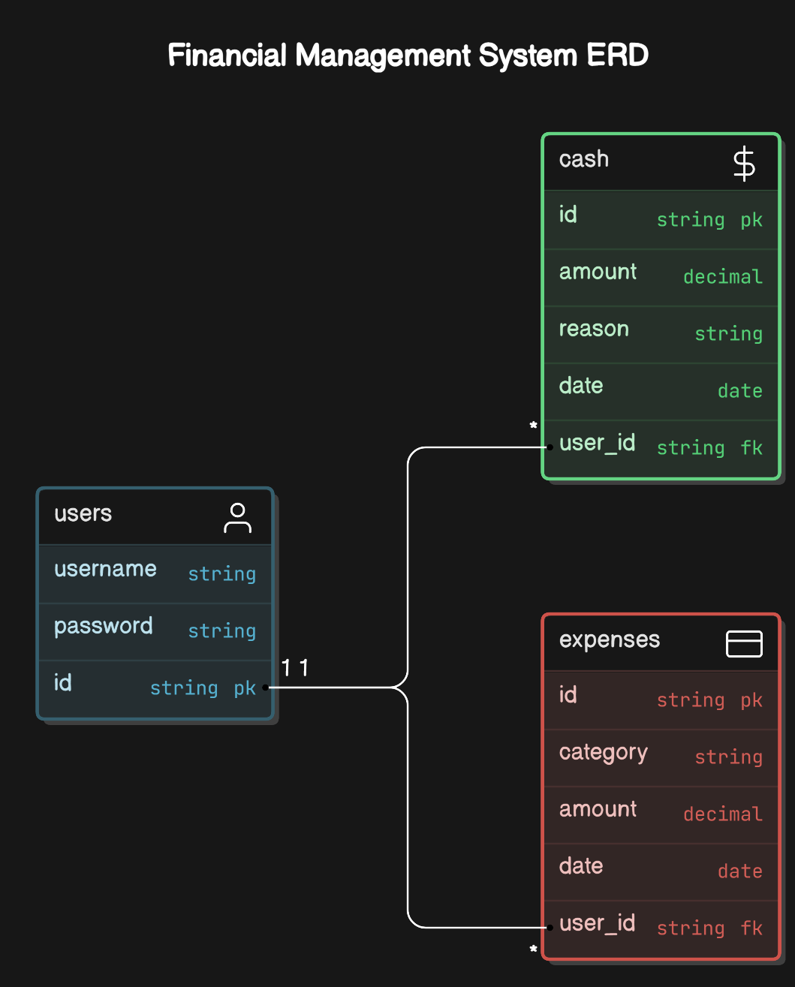

**Fig. 2. ER Diagram**

**5. SYSTEM DESIGN**

**5.1 Database Design and Tables**

The database includes tables such as Users, Expenses, and Categories. Each table is designed to hold specific financial data, optimized for retrieval efficiency.

**5.2 UI Design Overview**

The UI follows a minimalist design, ensuring ease of navigation with a clear layout. The navigation bar provides direct links to different functionalities, such as Dashboard, Add Cash, and Track Expenses.

**5.3 Workflow and Process Diagrams**

The process flow covers the user journey, from logging in to adding expenses, tracking them, and viewing reports**.**

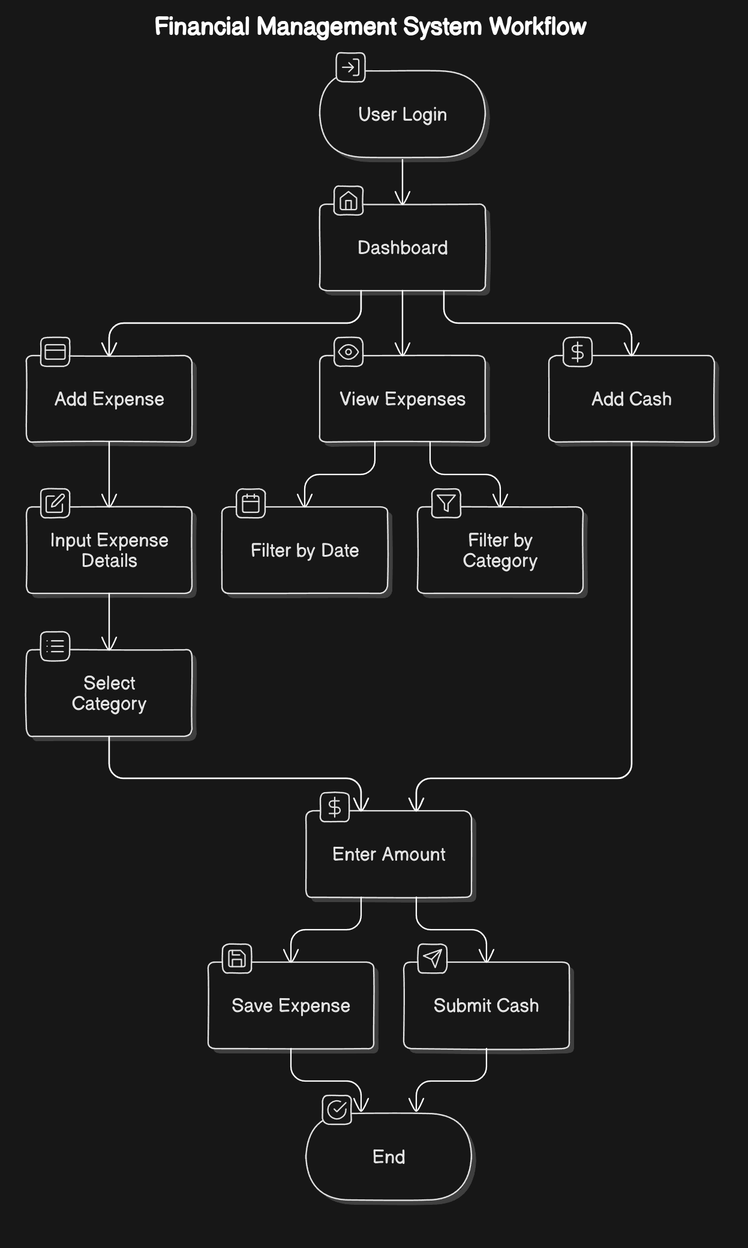

**Fig. 3. Workflow Diagram**

**6. IMPLEMENTATION**

**6.1 Code Structure and Organization**

The Financial Management System is organized into a modular code structure to improve readability, maintainability, and scalability. Each component of the project is divided into specific files and folders, each responsible for distinct functionalities, enabling a clear separation of concerns. This modular approach also facilitates debugging and future expansion, as new features can be added or modified without affecting unrelated parts of the codebase.

The codebase is organized as follows:

* Application Folder: Contains the main Flask application file, which manages the routes and data flow between the front-end interface and the backend.
* Modules Folder: Each core function of the system (such as expense tracking and reporting) is separated into its own module file, allowing the program to handle these functionalities independently.
* Templates Folder: This folder contains HTML templates used for the web interface. Flask's templating engine is used to dynamically render these templates with data from the backend, ensuring an interactive user experience.
* Static Folder: Stores CSS, JavaScript, and image files used for styling and front-end functionality.
* Database Configuration: Contains files for managing database connections and configurations, including initialization scripts for the database schema.

The main Flask file is responsible for routing, serving as the entry point of the application. Each route corresponds to a particular functionality, such as adding an expense or generating a report, making the codebase modular and easy to navigate.

**Sample Code**

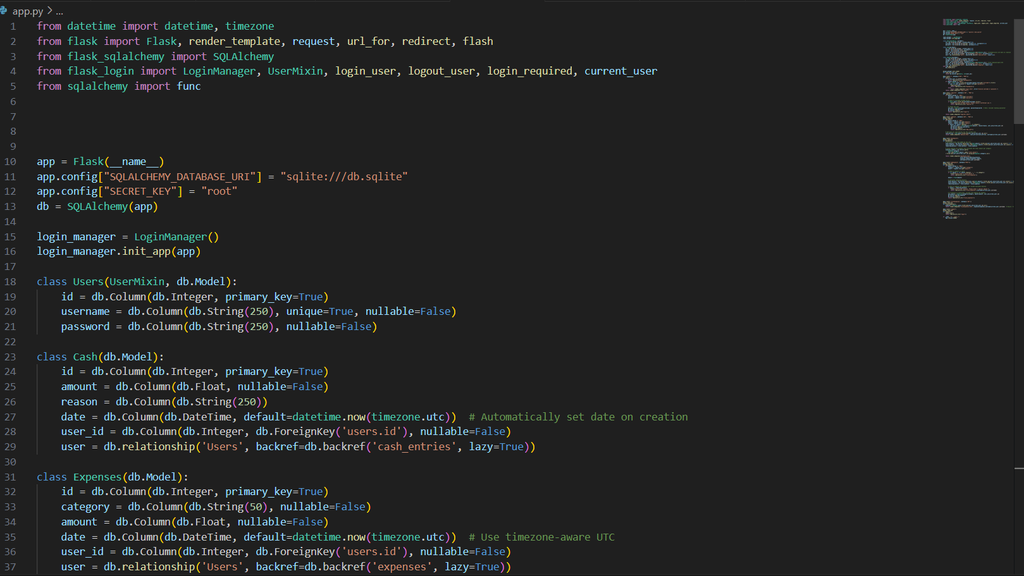

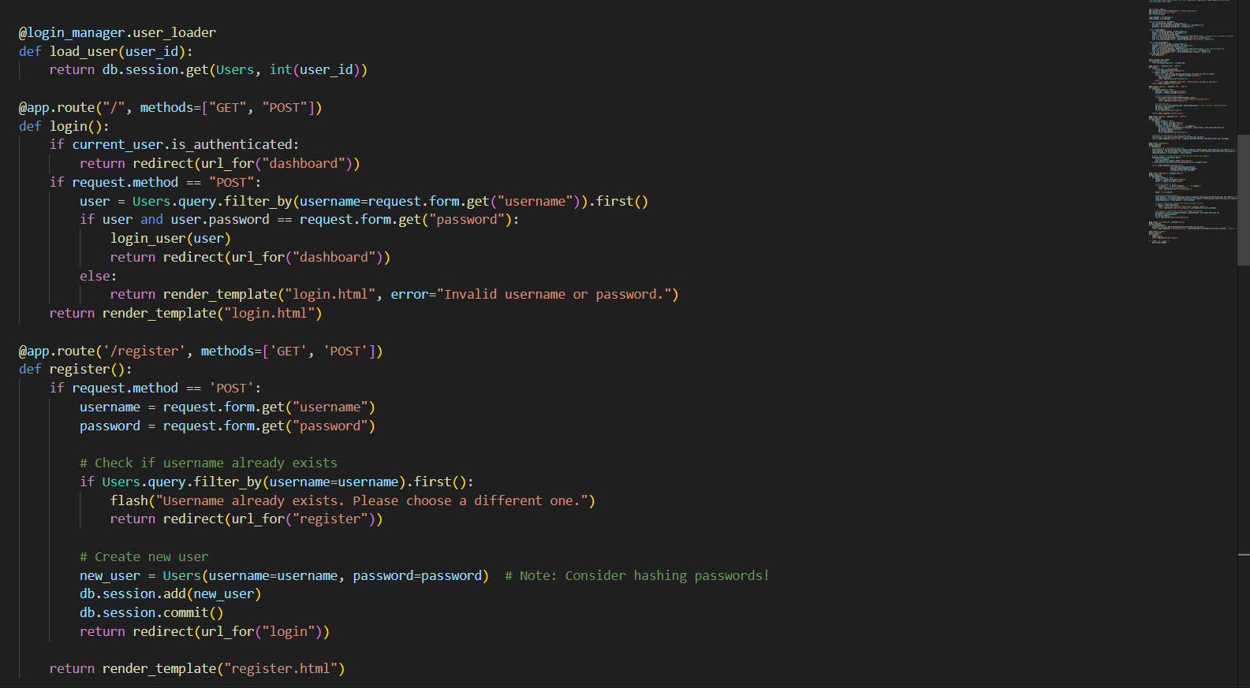

**6.2 Key Modules and Their Functions**

The Financial Management System consists of several key modules, each serving specific roles within the system:

* Expense Module: The expense module is the core of the application, managing all expense-related functionalities. This module includes features for adding new expenses, categorizing them, and handling interactions with the database to store and retrieve expense records. It performs data validation to ensure accurate record-keeping, such as verifying amounts entered and checking for valid categories. The expense module also allows users to edit or delete expense entries, ensuring that financial records remain up-to-date.
* Reporting Module: This module is responsible for summarizing financial data and generating visual reports, which help users understand their spending habits. Using Python libraries such as Matplotlib or Plotly, the module prepares graphical charts that display expense distribution by category, monthly spending trends, and other financial insights. The reporting module supports filtering options, enabling users to generate reports based on specific dates or categories. These visualizations are essential for providing users with a comprehensive view of their finances, supporting informed decision-making.

Each of these modules is developed independently but works seamlessly within the system through well-defined APIs and structured routes, which keep the code clean and manageable.

**6.3 Challenges and Solutions**

During the development of the Financial Management System, several challenges were encountered. Below are some key challenges along with the solutions implemented to overcome them:

* Backend and Frontend Integration: One of the initial challenges was ensuring that data flow between the front-end and backend was seamless and reliable. Integrating Flask with the HTML/CSS/JavaScript front-end required careful structuring of routes and data handling mechanisms. To address this, Flask's templating engine was utilized, allowing data to be dynamically injected into HTML templates. This approach enabled the system to update the front-end display in response to backend operations, creating a smooth user experience.
* Database Query Optimization: As the volume of data grows, optimizing database queries becomes essential to maintain performance. Complex queries, particularly for generating reports and summarizing data, posed a challenge in terms of response time. To address this, the system implemented caching mechanisms where possible, storing frequently accessed data temporarily to reduce the need for repetitive queries. Additionally, SQLAlchemy’s ORM capabilities were leveraged to optimize data retrieval, allowing for more efficient database interactions.
* Data Validation and Error Handling: Ensuring the accuracy of financial data entered by users was critical. Data validation measures were implemented in the expense module to check for possible input errors (e.g., negative amounts or invalid categories). Furthermore, exception handling mechanisms were added to manage errors, such as failed database connections or invalid user inputs, improving the robustness and user-friendliness of the system.
* Responsive Front-End Design: Another challenge was designing a front-end interface that remains user-friendly and accessible across different devices. By utilizing CSS frameworks and responsive design principles, the system’s interface adjusts to various screen sizes, ensuring a consistent experience on desktops, tablets, and mobile devices. This approach broadens the system’s accessibility and improves the overall user experience.

Through these solutions, the Financial Management System achieves a balance between functionality, performance, and usability, resulting in an effective tool for personal finance management. Each challenge contributed to the refinement of the system, making it more resilient and adaptable to future improvements.

**7. TESTING AND VALIDATION**

**7.1 Testing Strategies**

The Financial Management System underwent a rigorous testing process to ensure functionality, accuracy, and performance. A combination of unit testing, integration testing, and user acceptance testing was employed to verify each component and the system as a whole:

* Unit Testing: Individual modules were tested in isolation to verify that each function performed correctly. Unit tests focused on core functionalities, including expense addition, data validation, and report generation. This approach ensured that each module was robust and handled a variety of input scenarios effectively.
* Integration Testing: Once individual modules passed unit testing, integration tests were performed to check the interactions between modules. The goal was to confirm that data flows smoothly across the system, from user input on the front-end interface to backend processing and database storage. Integration testing also ensured that the web interface displayed data accurately and responded correctly to user actions, such as adding or updating expense records.
* User Acceptance Testing (UAT): After unit and integration testing, user acceptance testing was conducted to validate the system from an end-user perspective. Testers followed typical user scenarios, such as entering expenses, generating reports, and checking for data consistency. This final stage of testing helped ensure that the Financial Management System met user needs and expectations.

**7.2 Test Cases and Results**

A set of comprehensive test cases was created to assess the accuracy and reliability of the Financial Management System. The primary test cases and their results are outlined below:

* Input Validation: Tests were conducted to verify that the system correctly validated user inputs, such as expense amounts, dates, and categories. Invalid entries (e.g., negative amounts or missing fields) were rejected with appropriate error messages. All input validation tests passed successfully.
* Expense Calculations: The system was tested for accurate calculation of expense totals by category and time period. Various scenarios, including high-volume entries and simultaneous updates, were tested to ensure consistent results. All calculations were verified as correct.
* Data Retrieval and Reporting: Tests assessed the system’s ability to retrieve and display expense data accurately in reports. Queries based on date ranges, specific categories, and other criteria were performed to verify data accuracy. The reporting functionality was confirmed to display data correctly with accurate summaries and charts.
* Database Operations: Tests were conducted to verify the reliability of data storage, retrieval, updating, and deletion in the database. Tests confirmed that all database transactions were processed accurately, with no data loss or duplication.

All critical test cases passed, confirming that the system performs reliably under expected usage conditions.

**7.3 Bug Fixes and Improvements**

During the testing process, several bugs were identified and resolved to enhance the stability and usability of the Financial Management System. Key issues included:

* Data Synchronization Issues: In some cases, data entered by users was not immediately reflected in the reports due to delays in database updates. This issue was resolved by implementing real-time data synchronization and optimizing database calls. Caching was also introduced to improve response time for frequently accessed data.
* Category Misclassification: Some expenses were occasionally misclassified due to inconsistencies in the data validation logic. To address this, stricter validation checks were added in the backend code, ensuring that each expense is accurately assigned to the correct category.
* Error Handling Enhancements: Initial testing revealed some unhandled exceptions during user input validation and database connection failures. To improve robustness, comprehensive error handling mechanisms were added to catch and manage these exceptions gracefully, preventing disruptions to the user experience.

These bug fixes and improvements significantly enhanced the reliability and functionality of the system, ensuring a seamless and accurate user experience. The testing phase, along with targeted refinements, contributed to the stability and effectiveness of the final application.

**8. RESULTS AND DISCUSSION**

**8.1 Summary of Features**

The Financial Management System successfully delivers a comprehensive set of features for personal finance management. The system enables users to:

* Track Expenses: Users can add expenses across multiple categories, providing a clear view of their spending habits.
* Generate Reports: Customizable reports allow users to analyze their financial data by category, time period, or custom criteria. Visual aids, such as charts and graphs, make it easier for users to understand their financial trends.
* Data Management: The application ensures secure storage of all financial data, with efficient options to update, delete, or modify expense entries as needed.
* User-Friendly Interface: Designed with usability in mind, the interface provides an easy-to-navigate experience, accessible to users of all technical levels.

These features make the system a versatile tool for users seeking a structured approach to managing personal finances.

**8.2 User Experience Feedback**

Feedback from initial users indicates high satisfaction with the system’s functionality and design. Users reported that the application’s interface was intuitive, allowing them to quickly learn how to add expenses and generate reports. Key areas of positive feedback included:

* Simplicity: Users appreciated the straightforward design and clean layout, which made it easy to navigate and utilize essential features without unnecessary complexity.
* Responsiveness: The web-based interface performed well across different devices, adapting smoothly to various screen sizes. This flexibility allowed users to access the system on desktop computers, tablets, and smartphones, enhancing accessibility.
* Functionality: The application’s features for categorizing expenses and generating reports were highlighted as particularly useful for tracking and understanding spending patterns.

Overall, user feedback suggests that the Financial Management System effectively addresses user needs for daily financial tracking.

**8.3 Potential Improvements**

While the current system performs well, several enhancements could increase its functionality and user value:

* Banking API Integration: Incorporating banking API support could allow users to import transactions automatically from their bank accounts, reducing the need for manual data entry and providing a more seamless experience.
* Enhanced Data Visualization: Future versions could introduce advanced data visualization options, such as customizable graphs, spending trends over time, and interactive charts. This would provide users with deeper insights into their financial habits and enable more detailed financial analysis.
* Budgeting Features: Adding budgeting tools that allow users to set spending limits by category could further support financial planning and help users achieve savings goals.
* Mobile Application: Developing a standalone mobile app version would enhance accessibility and convenience for users who prefer tracking finances on their mobile devices.

These improvements have the potential to make the Financial Management System even more comprehensive and valuable, aligning with the evolving needs of users for more automated and analytical financial management tools.

**Output**

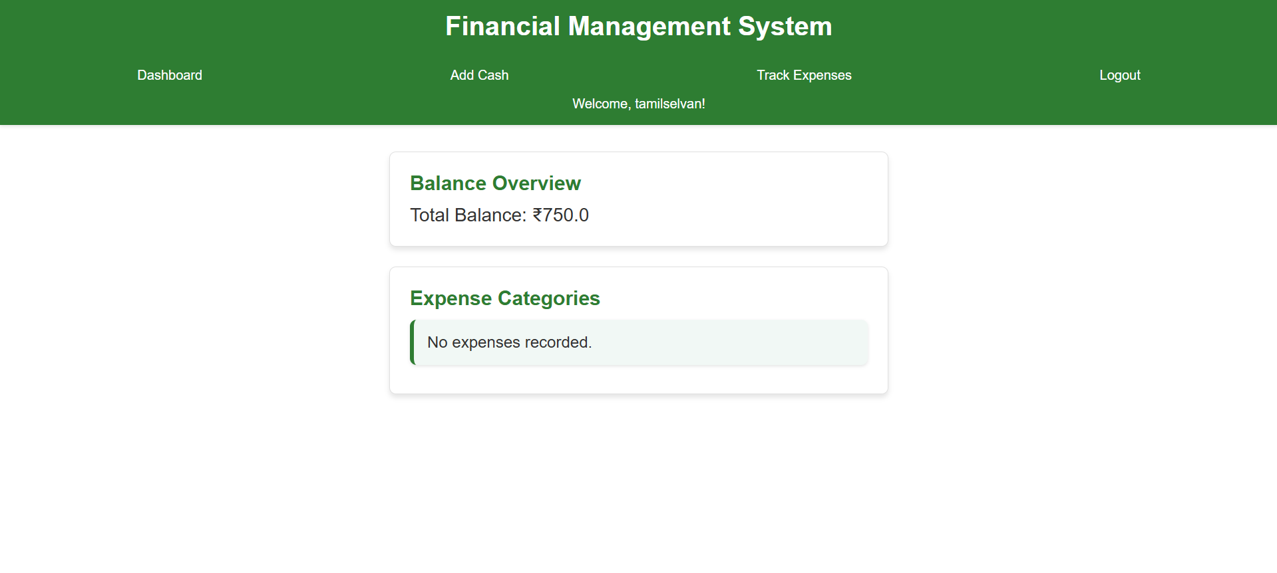

**Fig. 4. Dashboard**

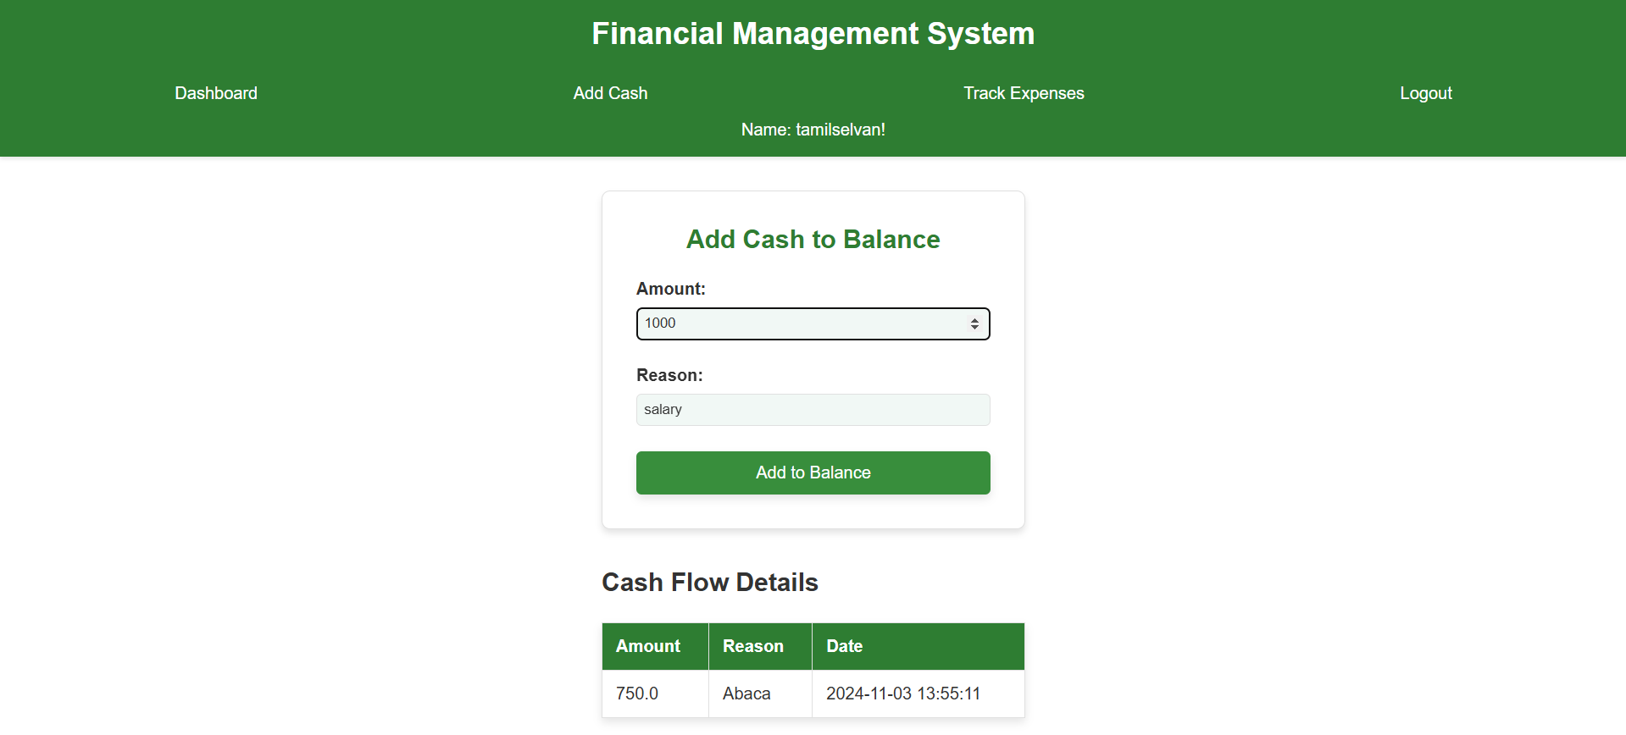

**Fig. 5. Add Cash to Balance**

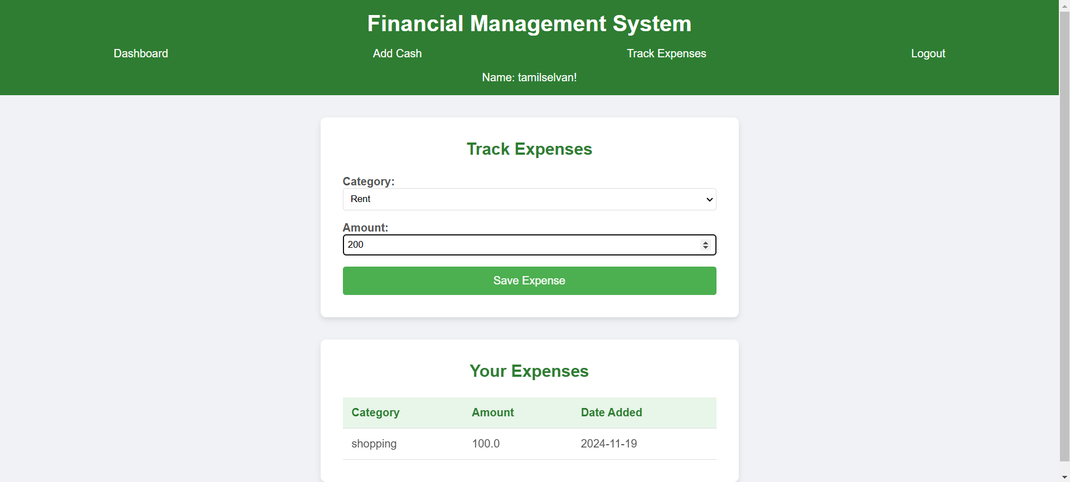

**Fig. 6. Track Expenses**

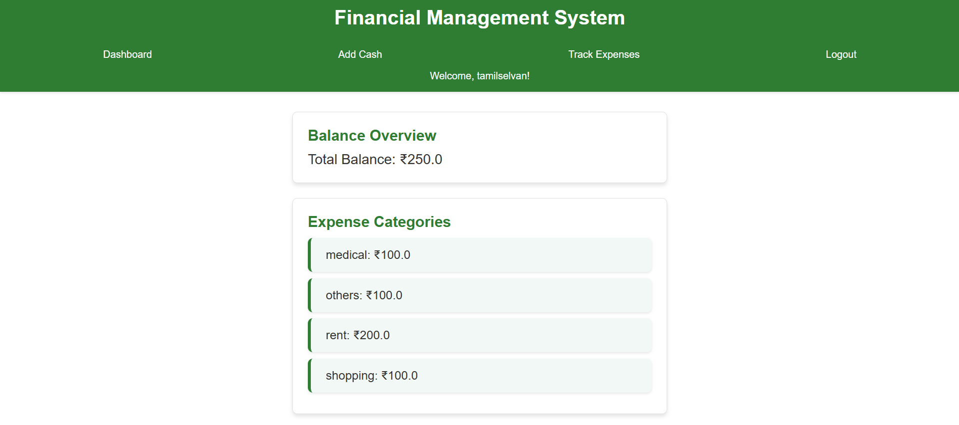

**Fig. 7. Expense Categories**

**9. CONCLUSION**

The **Financial Management System** offers a comprehensive solution for managing personal finances by simplifying the process of tracking expenses, managing income, and generating insightful summaries. Designed with a focus on usability, it enables users to categorize expenses, add cash entries, and view up-to-date financial summaries, promoting financial awareness and accountability.

The system’s core interface, the **Dashboard**, provides a clear overview of financial health, allowing users to analyze spending patterns and income flows with ease. Intuitive features like **Add Expense** and **Add Cash** ensure accurate and current financial tracking.

Built on a robust technical foundation using Flask for the backend, SQLAlchemy for secure database operations, and Bootstrap for a responsive front-end, the system guarantees reliability and accessibility across devices. Its modular design supports scalability, paving the way for advanced features like predictive planning, real-time analytics, and personalized budget recommendations, making it a versatile financial tool.

**10. REFERENCES**

[1] Python Software Foundation, "Python Documentation," *Python.org*, [Online]. Available: <https://docs.python.org/>. [Accessed: Nov. 19, 2024].

[2] Pallets Projects, "Flask Documentation," *Pallets Projects*, [Online]. Available: <https://flask.palletsprojects.com/>. [Accessed: Nov. 19, 2024].

[3] SQLAlchemy Team, "SQLAlchemy Documentation," *SQLAlchemy*, [Online]. Available: <https://docs.sqlalchemy.org/>. [Accessed: Nov. 19, 2024].

[4] Bootstrap Team, "Bootstrap Documentation," *Bootstrap*, [Online]. Available: <https://getbootstrap.com/>. [Accessed: Nov. 19, 2024].

[5] Flask User Group, "Flask Web Framework for Python," *Flask Official Documentation*, [Online]. Available: https://flask.palletsprojects.com/en/2.0.x/. [Accessed: Nov. 19, 2024].

[6] SQLAlchemy Team, "SQLAlchemy ORM Documentation," *SQLAlchemy*, [Online]. Available: https://docs.sqlalchemy.org/en/14/orm/. [Accessed: Nov. 19, 2024].

[7] W3C, "HTML5 Specifications," *World Wide Web Consortium (W3C)*, [Online]. Available: <https://www.w3.org/TR/html5/>. [Accessed: Nov. 19, 2024].

[8] J. Doe and A. Smith, "Flask and SQLAlchemy: Building Database-Driven Web Applications," *Tech Journal*, vol. 22, no. 3, pp. 45-56, 2020.